Robot Programming

• LO1: critically appraise the theoretical capabilities of existing state-of-the-art robot system algorithms and components

• LO2: understand and critically appraise the requirements and limitations of robot algorithms and components

• LO3: implement and empirically evaluate algorithms and components, by programming autonomous robots to perform complex tasks in dynamic environments • LO4: critically evaluate and comprehensively report implementation concepts and research findings



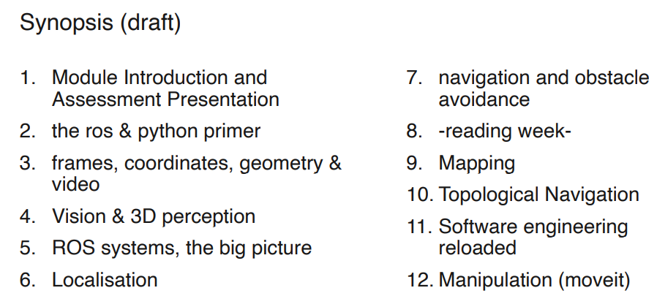

Overview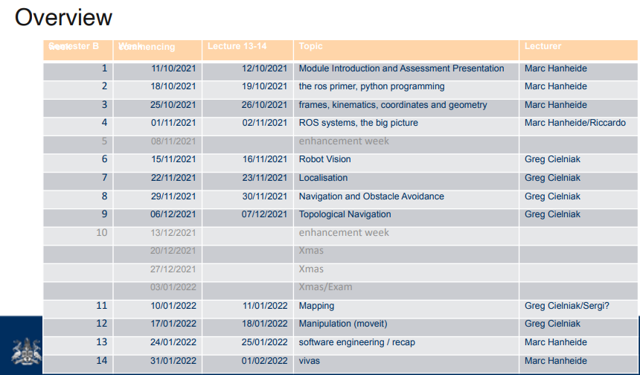

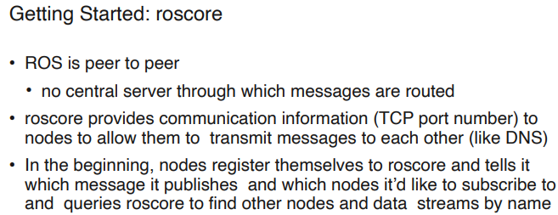

Worth watching undergrad AMR videos for new people if available?

For remote working, does splashtop still work?